Posted 11/8/2012 at 1:25 pm by JAV

Town Hall Building Committee

DRAFT Agenda
Library Conference Room (new library)
Tuesday, November 13, 2012
7:00 PM

- Discussion with Harvard Historical Commission (LLB) - 7:00
- Public Comment - 7:40
- Approval of prior Meeting Minutes - 7:50
- Invoice Approvals (If required) - 8:00
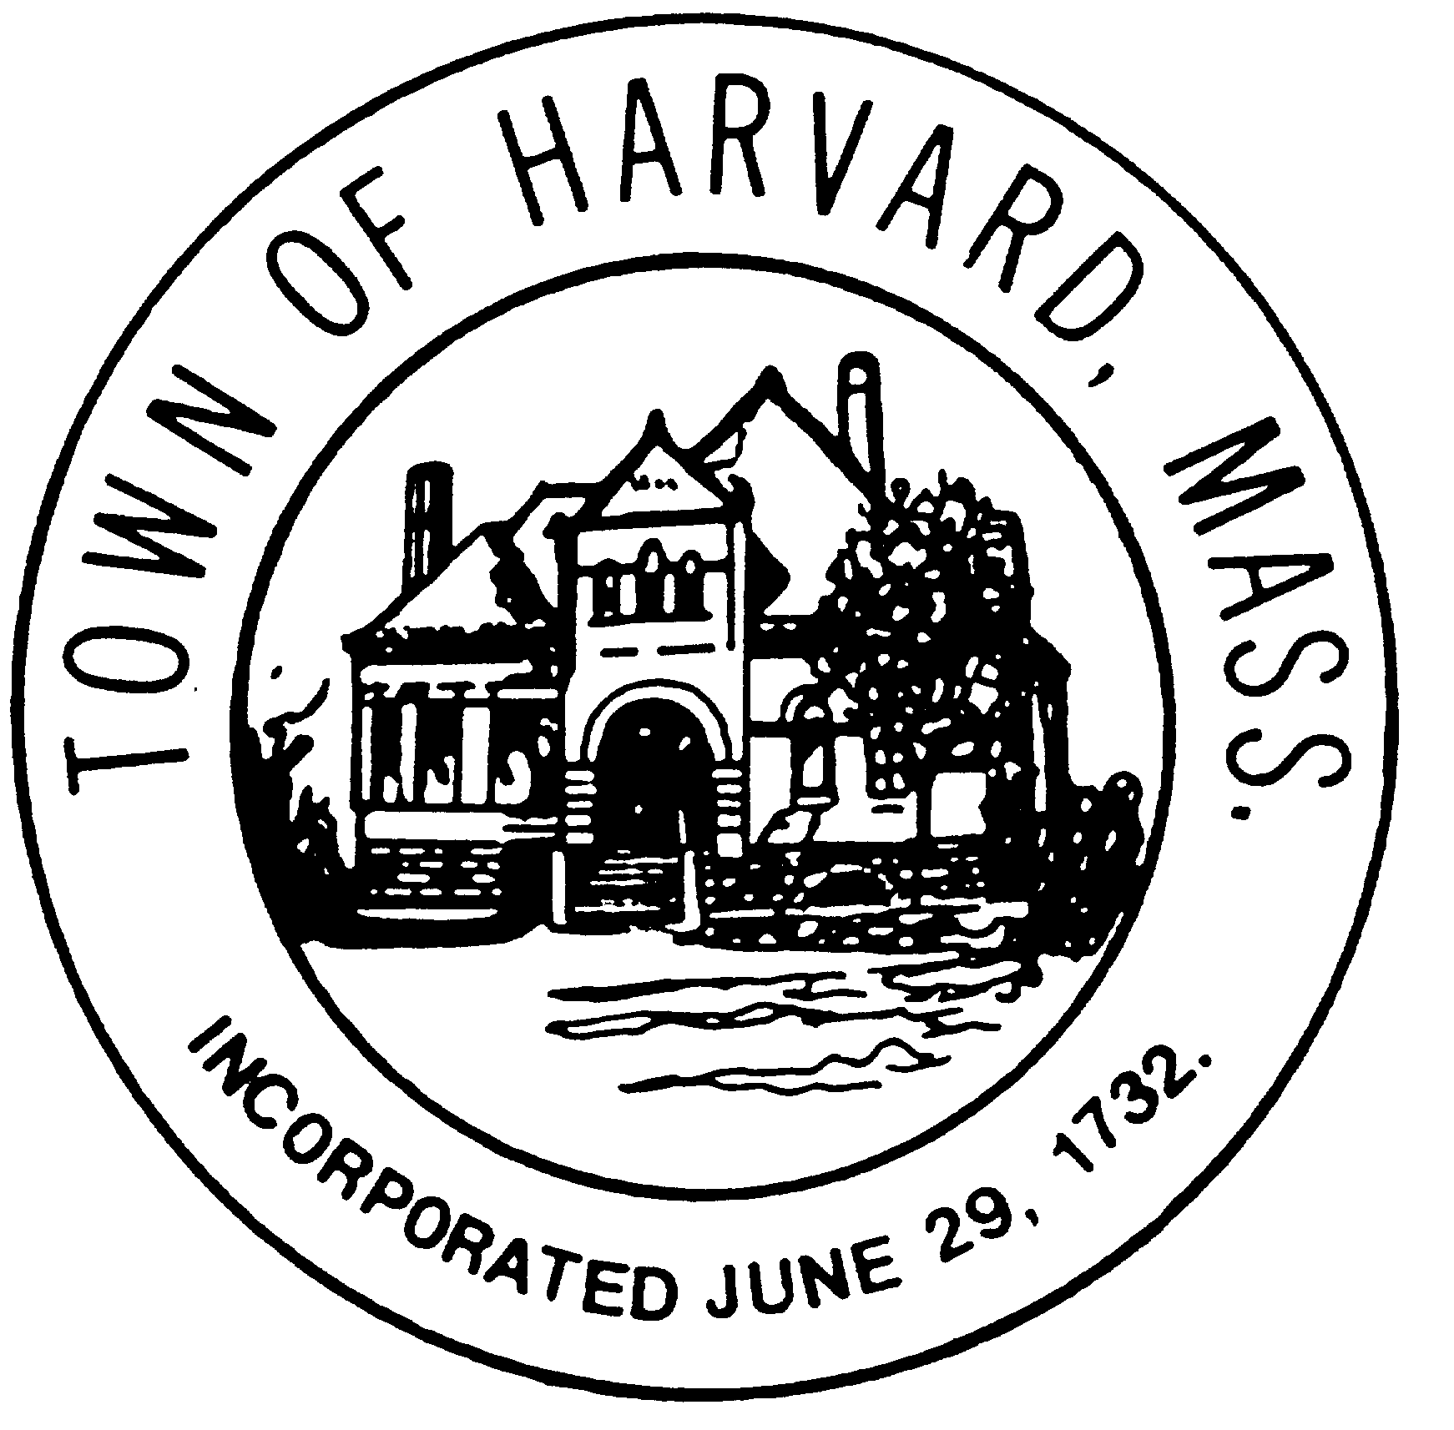
- Approve October 2 GPR proposal Tasks 6 through 9 - 8:10
- Design Development status (LLB) - 8:20
- Next steps for Design (LLB) - 8:30
- Discussion of BER comparison of FCU’s and chilled beam units - 8:40
- Review schedule and budget (John) - 8:50
- Other Business - 8:55

Next MBC Meeting Dates
  - TBD

